**Exercise 4: Handling Void Methods**Scenario:   
You need to test a void method that performs some action.   
Code:

package com.Mockito.Handling_void_methods;

public interface LoggerService {

void logMessage(String msg);

}

package com.Mockito.Handling_void_methods;

import static org.mockito.Mockito.*doNothing*;

import static org.mockito.Mockito.*mock*;

import static org.mockito.Mockito.*verify*;

import static org.mockito.ArgumentMatchers.*anyString*;

import org.junit.jupiter.api.Test;

public class LoggerServiceTest {

*@Test*

void serviceTest()

{

//create mock object

LoggerService logger=*mock*(LoggerService.class);

//stub the method

*doNothing*().when(logger).logMessage(*anyString*());

//call the method

logger.logMessage("this is the test bag");

*verify*(logger).logMessage("this is the test bag");

}

}

Pom.xml  
<project xmlns="http://maven.apache.org/POM/4.0.0" xmlns:xsi="http://www.w3.org/2001/XMLSchema-instance"

xsi:schemaLocation="http://maven.apache.org/POM/4.0.0 http://maven.apache.org/xsd/maven-4.0.0.xsd">

<modelVersion>4.0.0</modelVersion>

<groupId>com.Mockito</groupId>

<artifactId>Handling_void_methods</artifactId>

<version>0.0.1-SNAPSHOT</version>

<packaging>jar</packaging>

<name>Handling_void_methods</name>

<url>http://maven.apache.org</url>

<properties>

<project.build.sourceEncoding>UTF-8</project.build.sourceEncoding>

</properties>

<dependencies>

<dependency>

<groupId>junit</groupId>

<artifactId>junit</artifactId>

<version>3.8.1</version>

<scope>test</scope>

</dependency>

<dependency>

<groupId>org.mockito</groupId>

<artifactId>mockito-core</artifactId>

<version>5.12.0</version>

<scope>test</scope>

</dependency>

<dependency>

<groupId>org.junit.jupiter</groupId>

<artifactId>junit-jupiter-api</artifactId>

<version>5.9.3</version>

<scope>test</scope>

</dependency>

</dependencies>

</project>

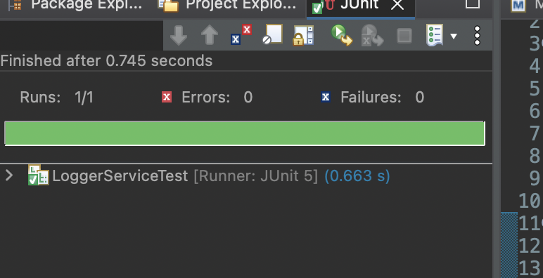

Output: